**2. COMCAST TELECOM CUSTOMER COMPLAINTS**

This project is based on an American Telecommunication based company who has received more than 1000 plus complaints in the year 2015 and later in 2016, they got penalised $2.3 million by the authorities for maintaining poor customer service.

Using the available dataset, a deep analysis is made on the type of complaints and period during which the complaints raised were high to figure out what went wrong in the customer service.

A necessary plots were made to better visualize the scenario and few insights regarding which states faced more issues with the service, what type of issues were highly reported along with their status(open/closed) were drawn during this project.

This analysis is done using R programming language and IDE used Is R-Studio. Below is the picture of it.

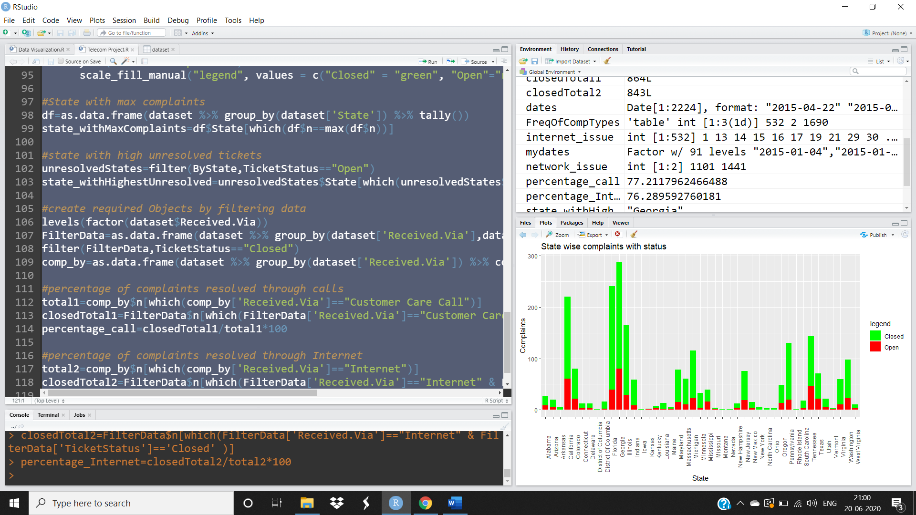

Below are the insights found after doing analysis on the company dataset:

1. The no.of complaints raised rapidly from second half of June till July 1st week
2. Georgia is the state with Highest complaints followed by Florida
3. There are very less network related issue compared to Internet issues but complaints from Other domains are very high
4. Tickets resolved percentage is almost same for case of people who reported through call or via internet
5. The Highest unresolved tickets are also from the state of Georgia

***Submitted by****:*

***U. SAI RAVI TEJA***